Zikang Chen, Hongxin Song, Tianze Zhang, Xinran Shen, Yating Yang, Enze Ma

COGS 118B

Professor Marcelo

03/11/2022

**Facial Age Recognition through K-Means and PCA**

**Introduction and Motivation**

The idea of this study is to discover to what extent facial age can be recognized through unsupervised machine learning algorithms like K-means and principal component analysis (PCA), building a trained model for distinguishing ages through face features. We separated data into three different age groups, each containing 180 pictures. They are grouped as children (sample age 5 years old), the middle-aged (sample age 34-40 years old), and the elderlies (sample age 81-93 years old) (Source: <https://www.kaggle.com/frabbisw/facial-age> ). We first conducted 2-component PCA and K-means clustering, then we furthered our study by adding t-SNE and CNN to get better results. The motivation of conducting this project is that facial recognition has become increasingly useful and brings many benefits in fields including security, health, biometric, cosmetology, and human-computer interaction.

**Related Work**

We review many facial age detection literature and find that many of the early approaches employ classification schemes that have trouble classifying unconstrained images. Many regression techniques such as Support Vector Regression (SVR) , linear regression, and Canonical Correlation Analysis (CCA) were used. More recently, a commonly used method is the Convolutional Neural Network (CNN), which learns and differentiates facial features to obtain the relevant information to predict human age. (Levi, Gil, and Tal Hassner, 2015)

For methods similar to our approach, regarding unsupervised learning methods for age estimation, there is a study conducted by Farhang on face extraction based on K-means clustering from images. This study showed that the K-means clustering algorithm could extract faces from images. This method divides a set of objects into subsets in a way that similar objects are placed within a cluster. This algorithm increased the accuracy rate and reduced the number of iterations, intra cluster distance, and the related processing time. (Farhang, 2017)

There are also studies conducting Principal Component Analysis on facial recognition. Barnouti etc. propose an automatic facial detection by projecting the image onto the Eigenface space by PCA. Training and testing set images were projected on Eigenfaces and Euclidean distance was measured between each testing and training image. Then, age of image from the testing dataset was determined based on the closest image from the training dataset. (Barnouti, 2016)

**Methods**

1. **PCA (principal component analysis)**

We obtained the pictures of faces of three age groups in three folders. We load the pictures by reading the files names and the folders they are in. We preprocess each picture by turning it into an array of pixels. We attach a label of age to each picture with a number associated with the folder it is in. We imported PCA from scikit-learn and fitted PCA with two components on the pictures of faces of three different age groups. We then applied dimensionality reduction to the data by using our fitted PCA.

1. **K-means**

We imported K-means from sklearn at first. Since the data comes from three different age groups, we assumed that the cluster number is 3. Then we perform K-means test and plotted out the cluster correlations.We also implemented our own version of K-Means algorithm to display graph for each cluster with the runKMeans function (updating cluster centers and the responsibility matrix until they converge), calcSqDistances (calculating the square of distance between data points and cluster center µ), determineRnk (calculating 𝑘 the entries 𝑟 in the responsibility matrix), and recalcMus.

1. **t-SNE and check the basic model**

We found it impossible to separate the data by using PCA to reduce the dimension to two so we tried t-SNE to reduce the dimension of the data to two because it's one of the best methods to reduce the dimension for visualization, but they are still inseparable. So we assume that may be because we reduce the image too much and we lost too much information by this process, so we again try to use PCA but this time we reduce the data to 20 dimensions. We use the data to fit K-means into 3 clusters and make the prediction by K-means for data, then we get a new label list, account the number of each age in each cluster, they still cannot be well separated but this time we can find some kind of trend. But we are still unsatisfied with what we got, so we may improve it.

1. **CNN**

We import the pre-trained resnet50 from torchvision.model, we put the images into the model and get outputs as our new data. We try to visualize the data after the CNN, so we still use 2-component PCA and t-SNE to reduce the dimension, but they are not that good. But the PCA data actually look separate a little bit, so we decide to use another PCA to reduce the dimension to 20 and try K-means on it. We fit K-means and repredict the data, accounting for the number of each age in each cluster. We can see that the trend does become better. But because resnet50 is not trained for face recognition, so we use one more type CNN, vggface2

We put the images into the model and get outputs as our new data. After visualization, we find that it probably becomes worse. Then, we performed a 20-component PCA in the same procedure, but the result became worse.

**Result**

We performed PCA with two components on the data. The results showed reduced dimensionality, as we can see from the output of performing PCA on our dataset of faces. 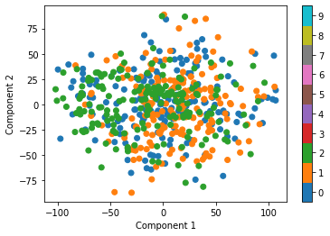

Figure 1: The plot of the data projected onto the principal components. The blue dots (0) represent the images of the elderlies, the orange dots (1) represent the middle-aged, and the green dots (2) represent the children. As we can see, the dots are all clustered together without any noticeable patterns and they are not classified into different clusters, so PCA with 2 components cannot cluster the images into different age groups.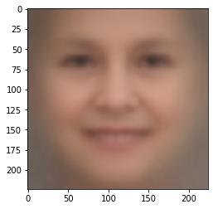

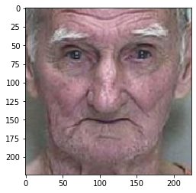

Example: **Left**: The original image of the face of an elderly. **Right**: The image reconstructed from the projected data.

We can tell that the picture on the right does not look like the original image. Therefore, PCA with 2 components fails to reconstruct the original image accurately.

When we tried to use the K-means method imported from sklearn, the result was not what we expected as the clusters did not show any obvious patterns. Thus we tried to implement K-means using our own algorithms. We were able to get three different clusters of faces after running our K-means algorithm on the dataset with 180 samples of faces from each age group, yet it still did not work as well as we expected as it did not cluster the faces into the corresponding three different age groups. As we can see, the three clusters are mainly different in their background color and shades. We can vaguely see that the first cluster represents an older age than the last two two, but it’s not enough to tell what age group each cluster represents. Also the last two clusters seem very similar besides their background color. So we were not able to cluster faces exactly by different ages.

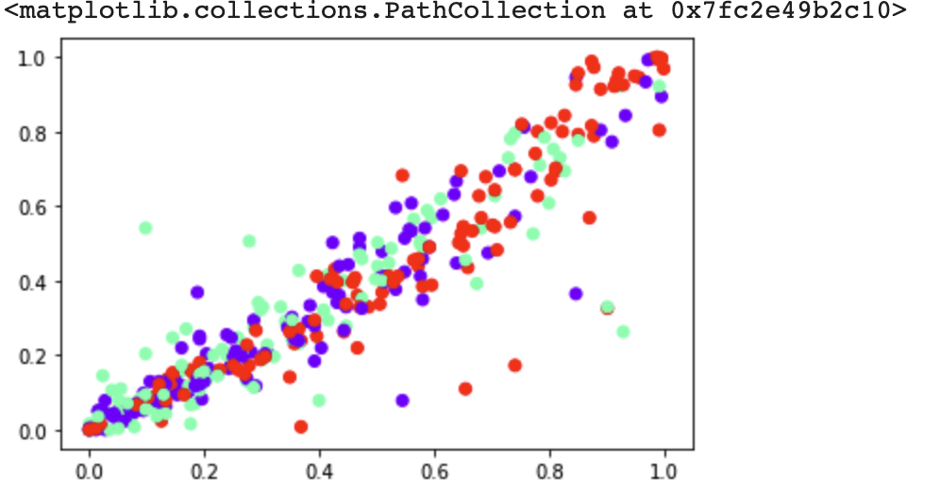

Figure 3: The plot of the data classified into 3 clusters labeled with different colors that represent different age groups.

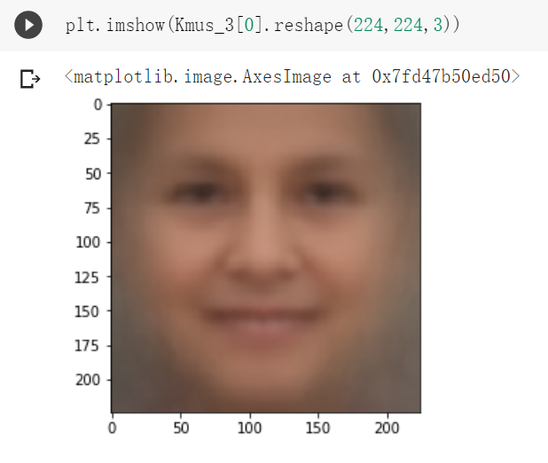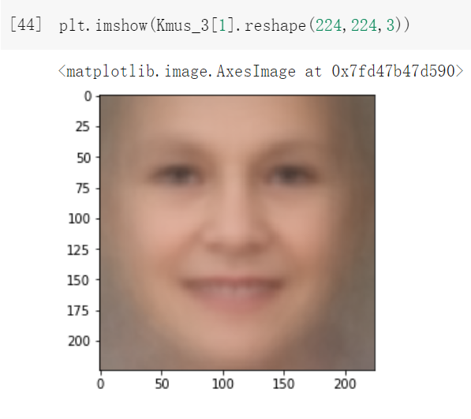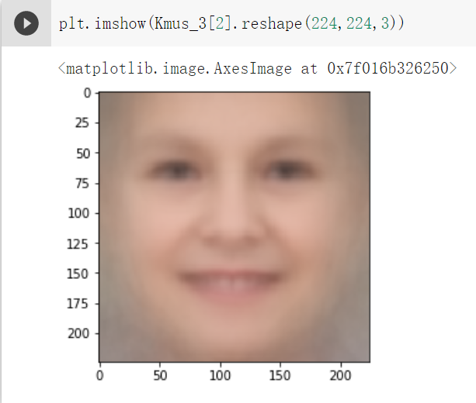

Figure 4: The 3 images reconstructed from the 3 clusters.

vis-RESNET PCA t-SNE

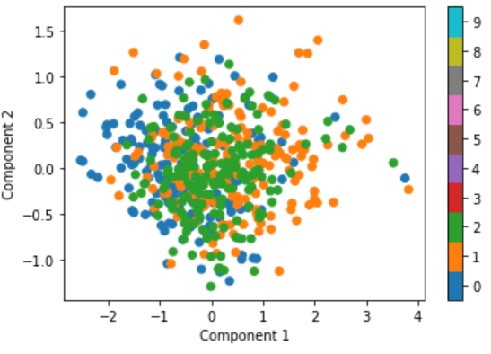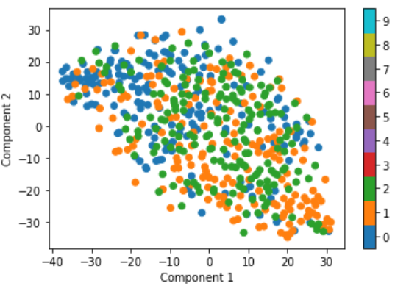

Note: from left to right is age 5, 90, 35

Then we use the 20-dimensional model PCA and K-means on original dataset we get

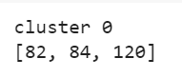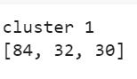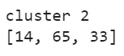

We can find that cluster 1 consists mostly of age 5. Even though the trend is not as good as we expect, that indicates we may find a kind of trend and feature by this process.

vis-vggface2 PCA t-SNE

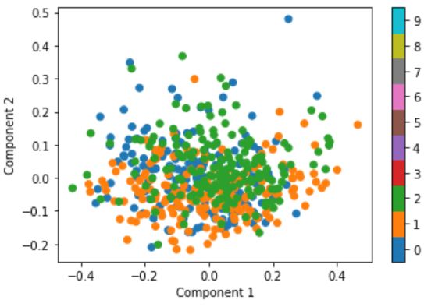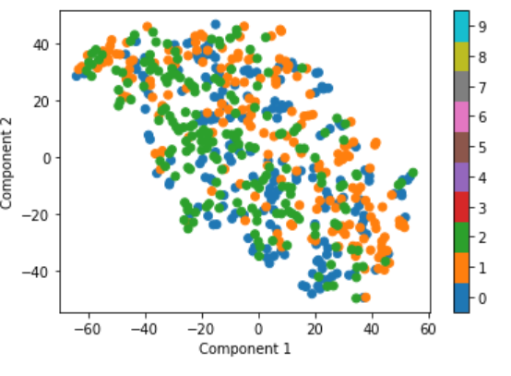

Then we use the 20-dimensional model PCA and K-means on resnet-50 dataset, we get

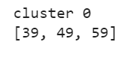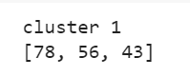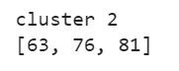

We can find that, cluster 0 age 90 are more than others. Cluster 1 mostly consists of age 05 and cluster 2 mostly consists of age 35 which is more than 50%. We can find that our model becomes better than before, even we still can’t separate them very well, but we actually can get something from this one, if K-means predicts some images to cluster 1 then it will most likely be age 5 and for cluster 2, it’s the same theory it will most likely be age 35. So we actually can predict something now which means we are learning more than before.

When we use the 20-dimensional model PCA and K-means on vgg-face dataset, we get

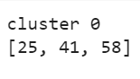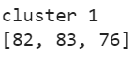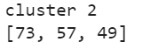

We can find we can’t actually get anything from this one, it’s even worse than not using vgg-face2. We think it is because we lose too much information when using PCA. Secondly, the vggface2 is trained for face recognition, not age prediction. The feature it extracts may need to be trained by a little more forward connected layer to fit the requirement. Because we are doing unsupervised learning here, we will stop here.

**Discussion**

The results that we get from the K-means are not as what we expected. From the images, there's not much difference other than the shade of color. From the scatterplot, we didn't notice any obvious clusters. This might be because the way that we distinguish people by age group is not as obvious as we thought. The faces look very similar. But at least we can get some information by our process as we can predict something by our resnet50 model, which means that we may actually find a way to finish the task. If we had more time, we think we can improve our work by choosing more different age groups that may be easier to distinguish. Or we can actually add more layers to the resnet50 or vggface2 and train them, and use that model to extract the feature from the image. Or simply use some other model to extract the image features and try different dimensions for PCA to keep most of the information. Another way to improve results is to increase the size of the dataset, since the dataset we have is kind of limited. We'll get more obvious results if the dataset is large enough. As for follow-up work, more data of people in different ages should be collected. This data can be used to further train this model to differentiate specific ages instead of blurry age classification like children, the middle-aged and the old.

**Contribution**

Zikang Chen: most of the code of PCA, method and results of PCA in the paper, results of PCA in the video

Enze Ma: Code of CNN, t-SNE. Method and Result of paper. CNN for video.

Hongxin Song: Code of K-means, method of K-means and introduction in the paper. Results of K-means for the video.

Xinran Shen: Introduction and related work in paper. helped on the code of PCA. Intro and related works in video.

Tianze Zhang: worked on code for K-means, results of K-means in the paper. Methods in the video.

Yating Yang: Discussion part in paper. Helped the code of CNN. Discussion in the video.

**Code**

<https://github.com/zterryy/cogs118b-final/tree/zterryy-cogs118-final>

**References**

The visualize_components function and part of the PCA codes were adapted from the Neuromatch Academy Tutorial. <https://colab.research.google.com/drive/1pUcW-w7VjC-AkBCpyFNhQr8DUeRwO7ek?usp=sharing#scrollTo=cFlK1crCXe5p>

Part of the code for loading and preprocessing the images from folders were adapted from the code by “STPETE_ISHII” on Kaggle. <https://www.kaggle.com/stpeteishii/facial-age-prediction>

Levi, Gil, and Tal Hassner. "Age and gender classification using convolutional neural networks." *Proceedings of the IEEE conference on computer vision and pattern recognition workshops*. 2015.

Farhang, Yousef. “Face Extraction from Image Based on K-Means Clustering ...” *Face Extraction from Image Based on K-Means Clustering Algorithms*, 2017, <https://thesai.org/Downloads/Volume8No9/Paper_14-Face_Extraction_from_Image_based_on_K_Means.pdf>.

Barnouti, Nawaf Hazim. “Face Detection and Recognition Using Viola-Jones with PCA ...” *Face Detection and Recognition Using Viola-Jones with PCA-LDA and Square Euclidean Distance*, 2016, https://pdfs.semanticscholar.org/2177/6cefbfc9274a17aab4f09b8018d032da4b3d.pdf.